**Scalefocus Homework No.9 – Linux Commands II**

***Mihail Elencevski***

1.Elevate your user access to root;

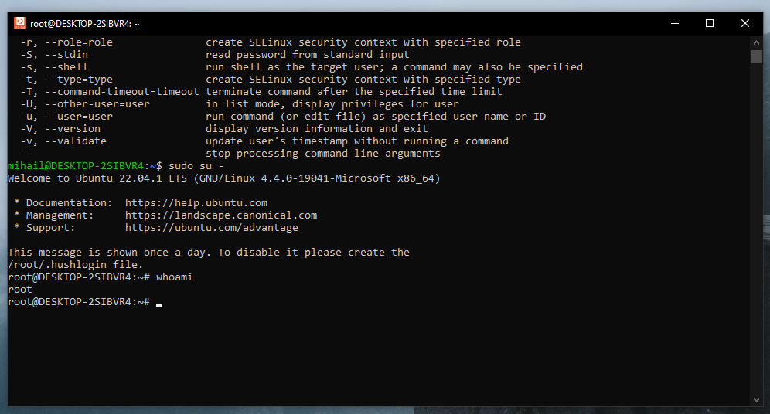  
2. Add a new user to your Linux OS and set a password for it;

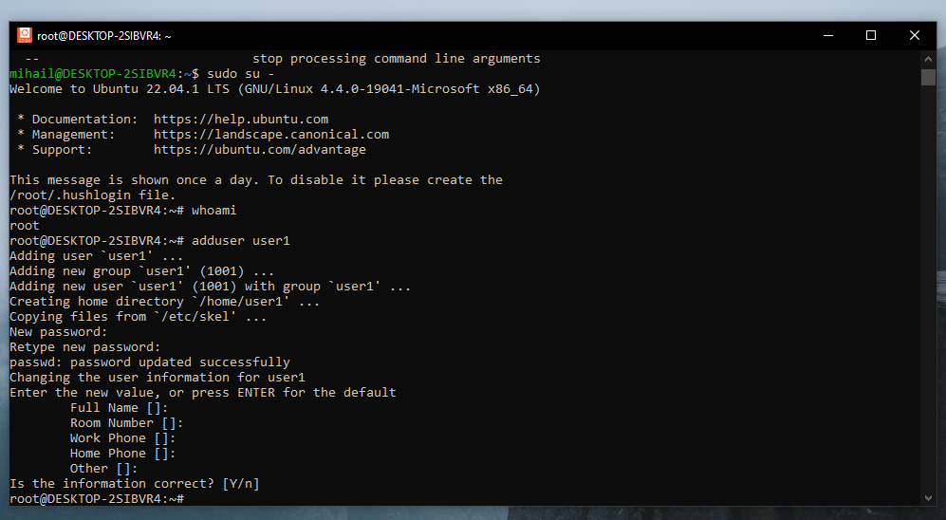

3. Test if you can log in using that user;

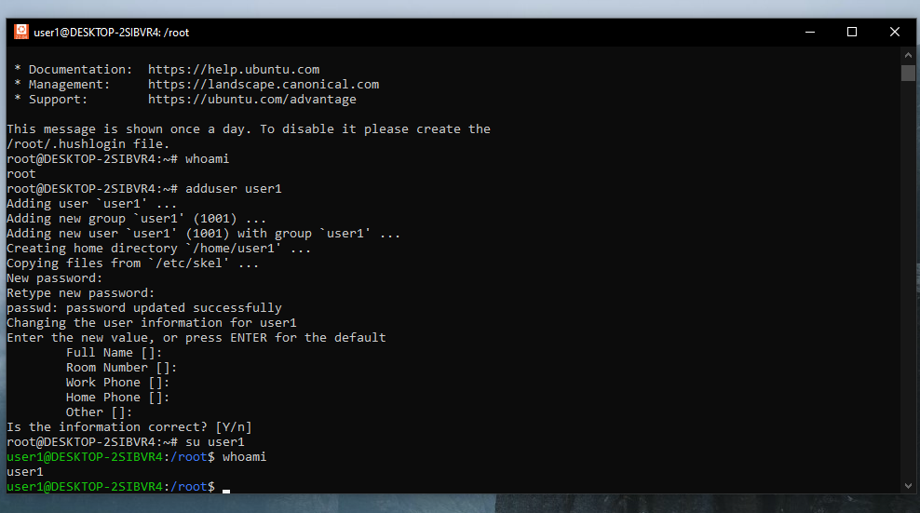  
4. Using grep command check if the user is created;

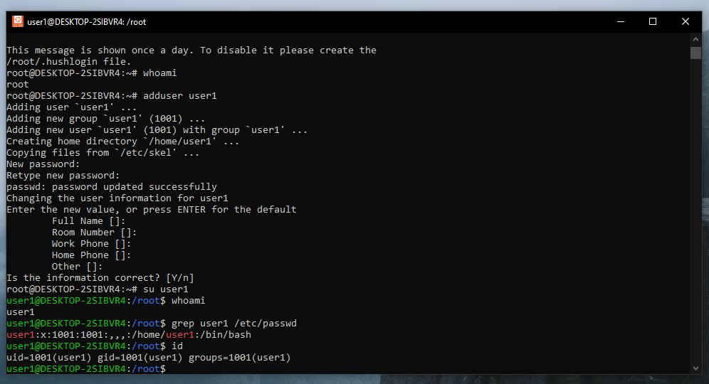

5. grep the UID of each user;

  
6. Find out the GID of the created user;

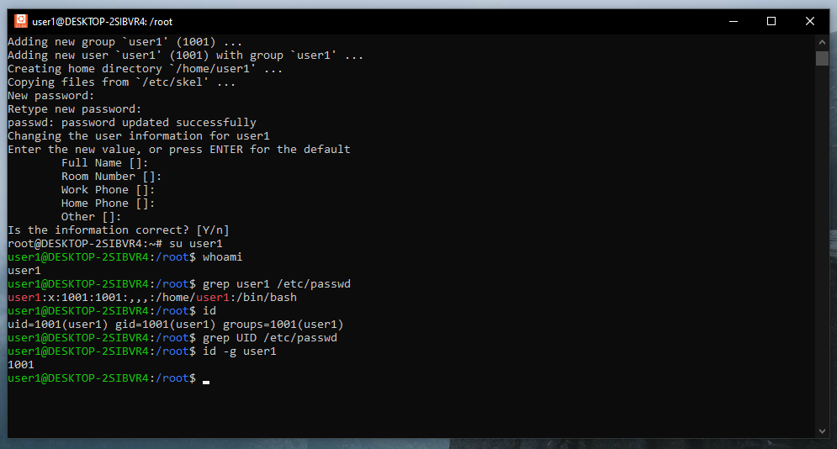

7. Change the password of the user and force it to change the pass on his next login;

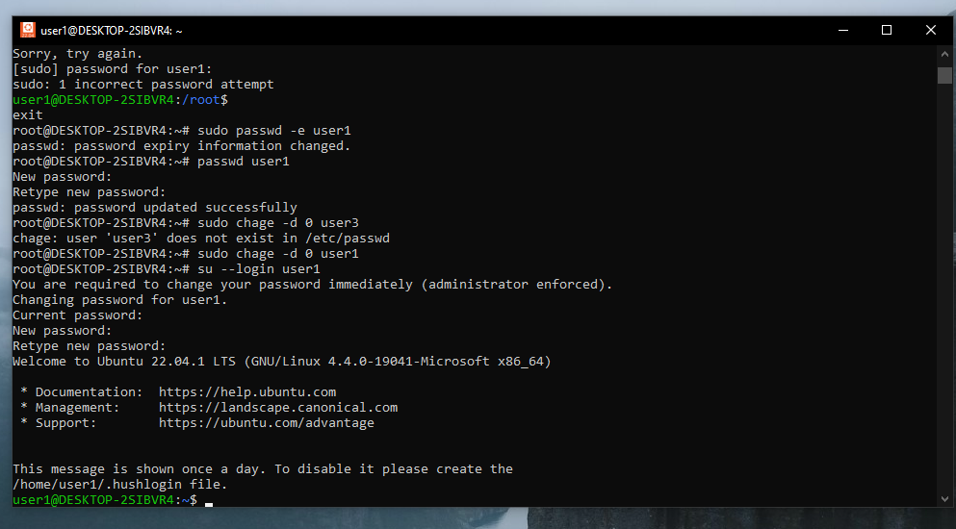  
8. Add a new user and set an expiration date for it, with a five-day warning period;

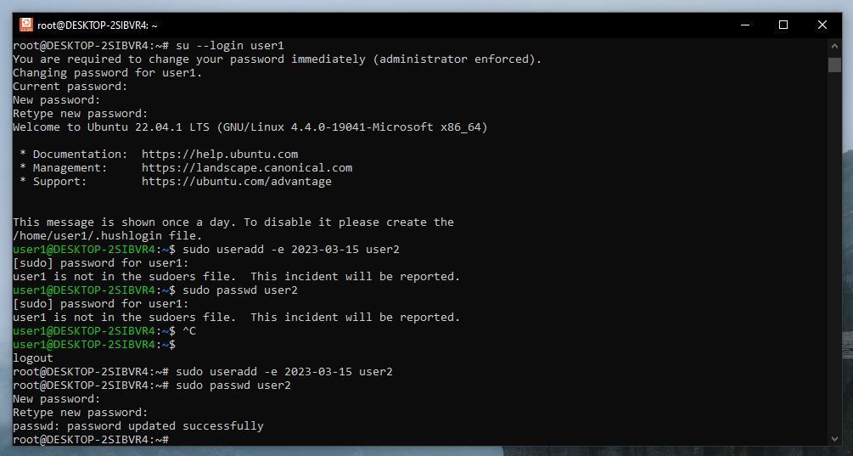

9. Create a new group;

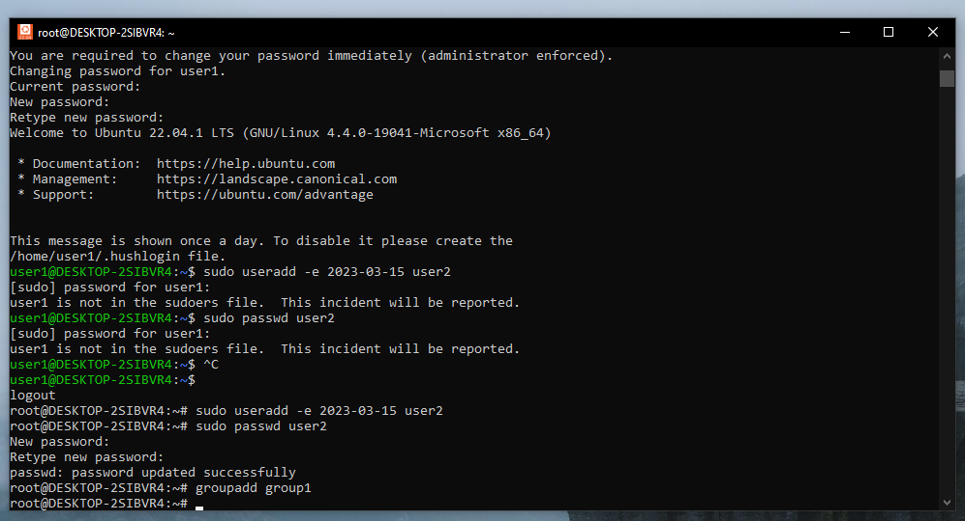  
10. Assign the two new users to that group;

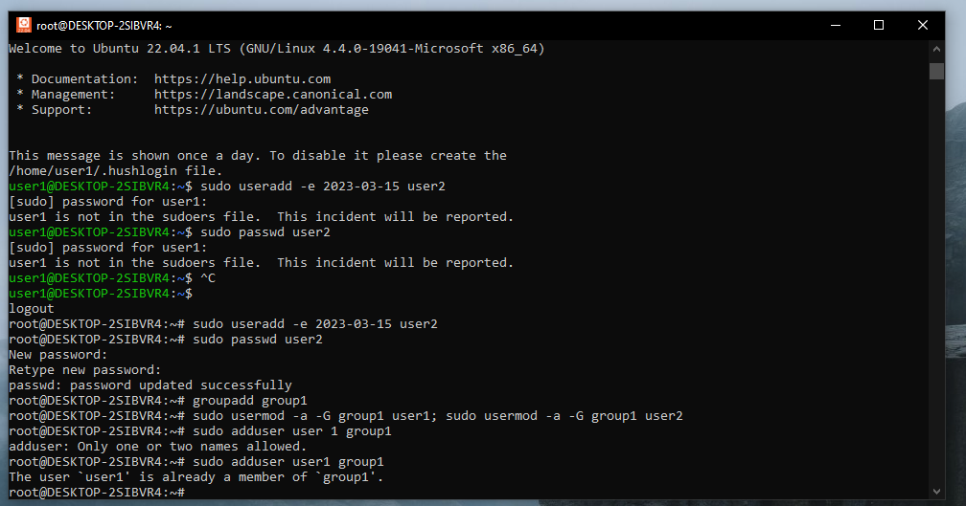  
11. Lock one of the user accounts;

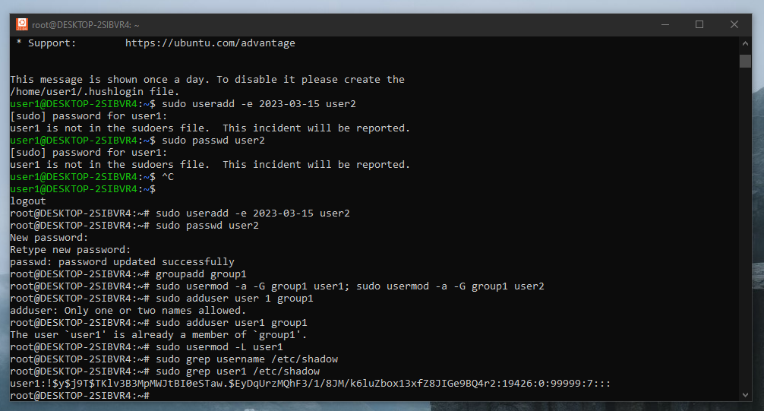  
12. Change the shell of one user to tcsh;

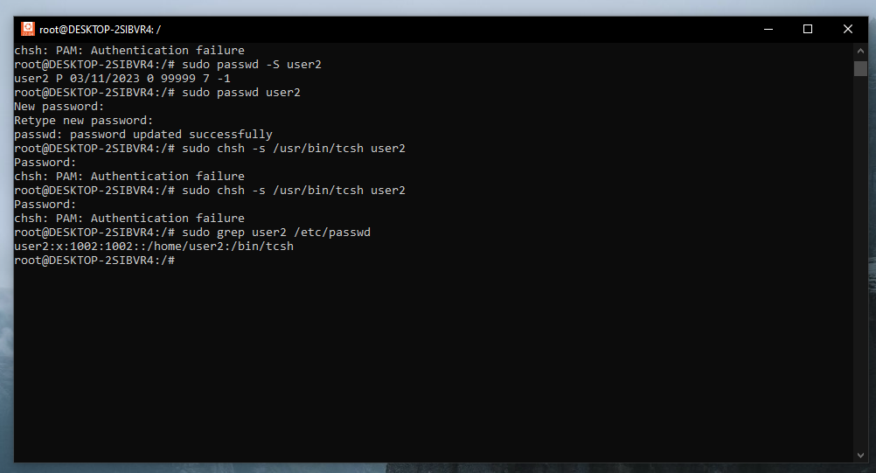

13. Make sure your home directory has “execute” access enabled for group and other.

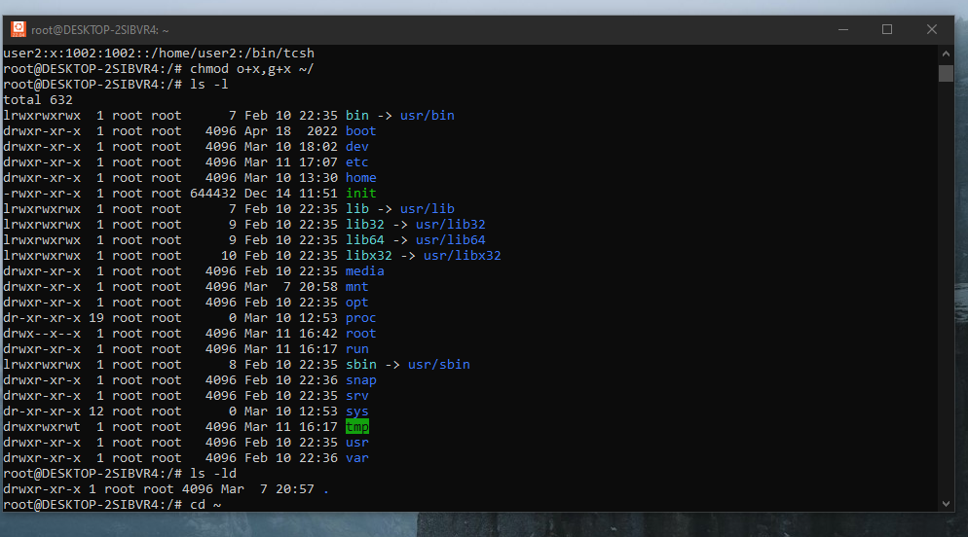

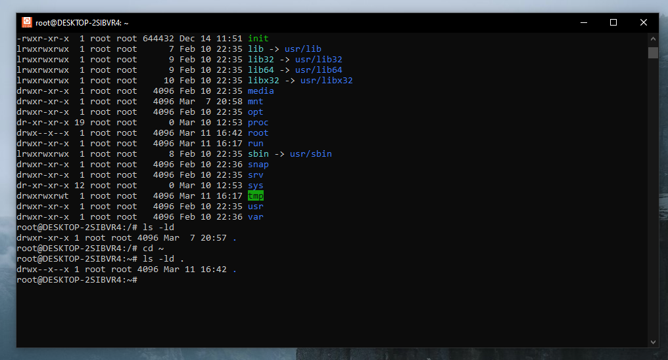

14. Change to your home directory, and create a directory called labs;

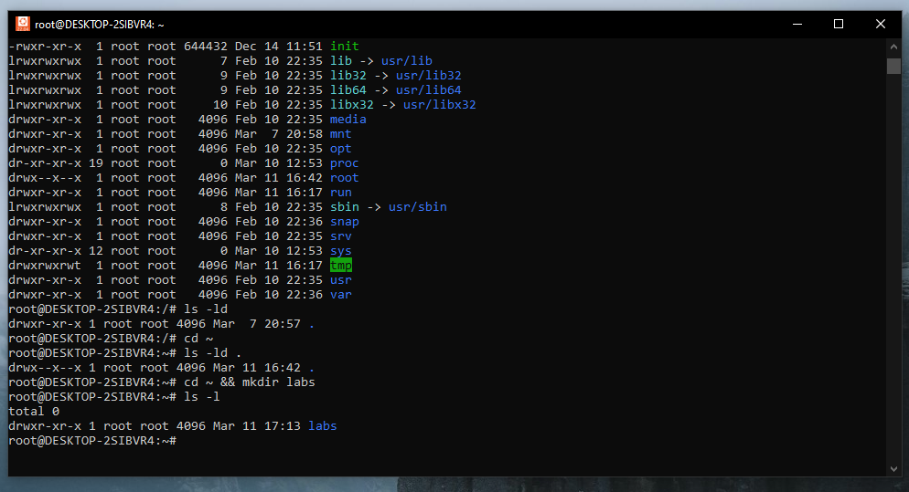  
15. Create an empty file in labs directory

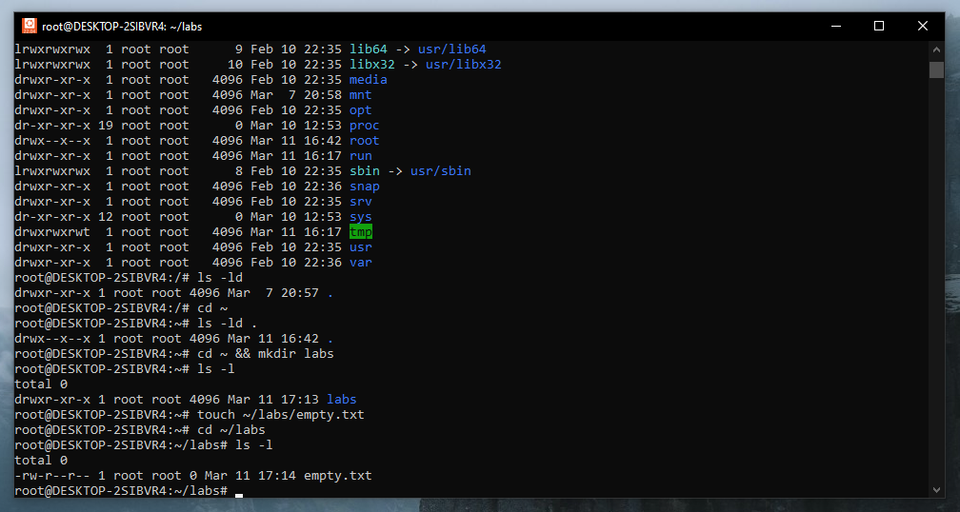

16. Change permissions of file to rwx-rwx-rwx  
69 Bulgaria Blvd., Infinity Tower B, fl. 8, Triaditza district, 1404 Sofia, Bulgaria | +359 2424 6484 | sales@scalefocus.com | [www.scalefocus.com](http://www.scalefocus.com)

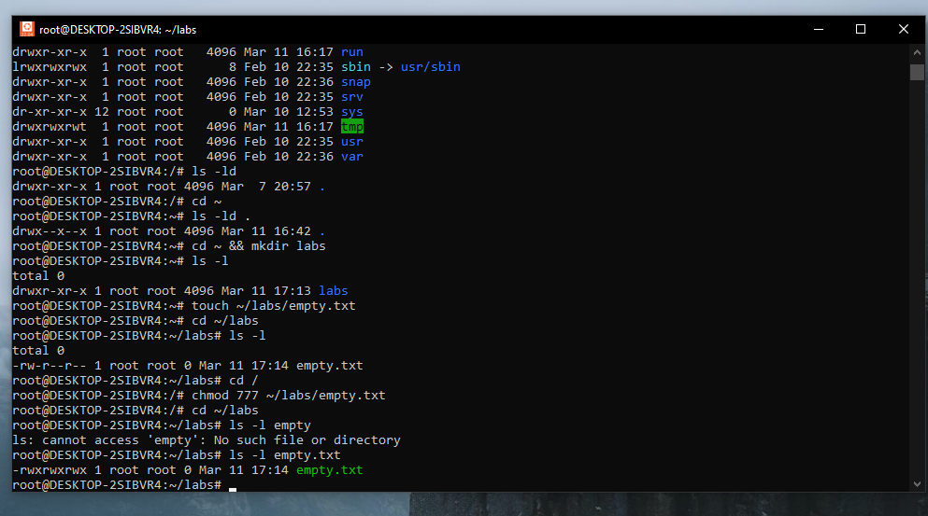

17. List the file. What color is the file?

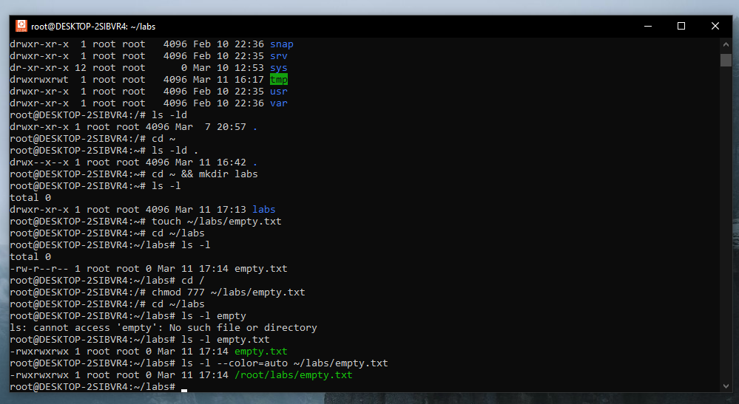  
18. Change the permissions back to rx-rw-rw

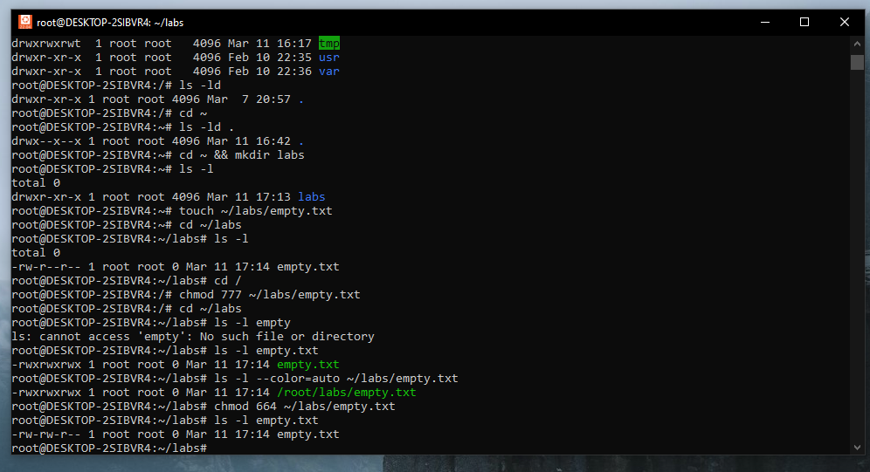  
19. Check what owners does the file have.

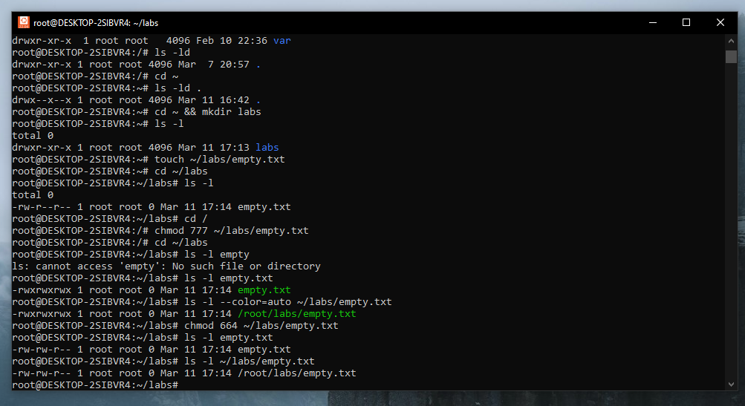

20. Change the user ownership of the file to another user;

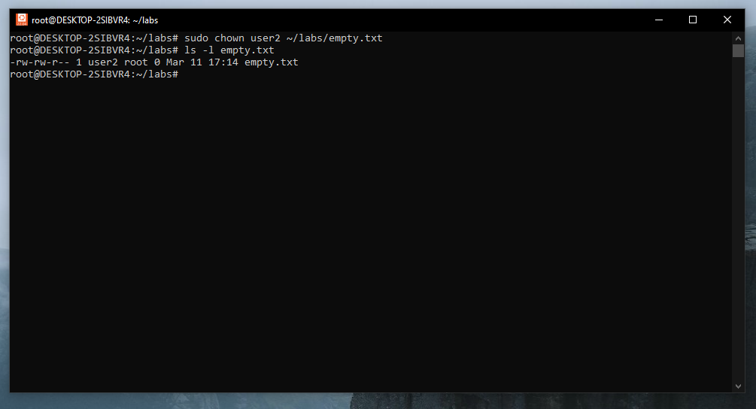  
21. Create a group called group1 and assign two users to the group;

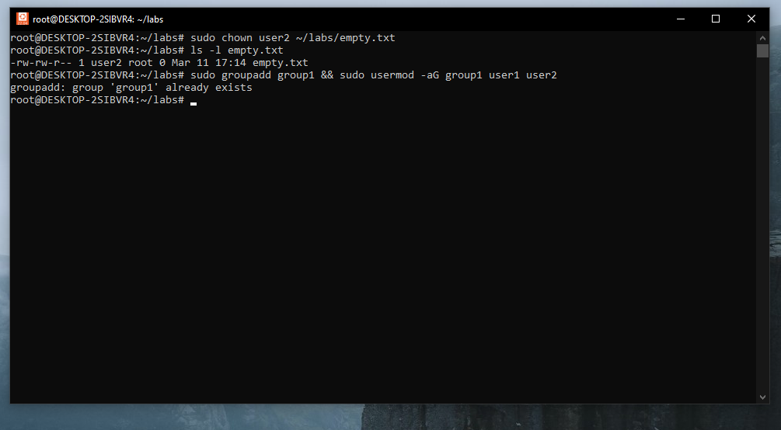

22. Create a file called group1.txt and redirect below input into the file:  
“This is our group test file”.

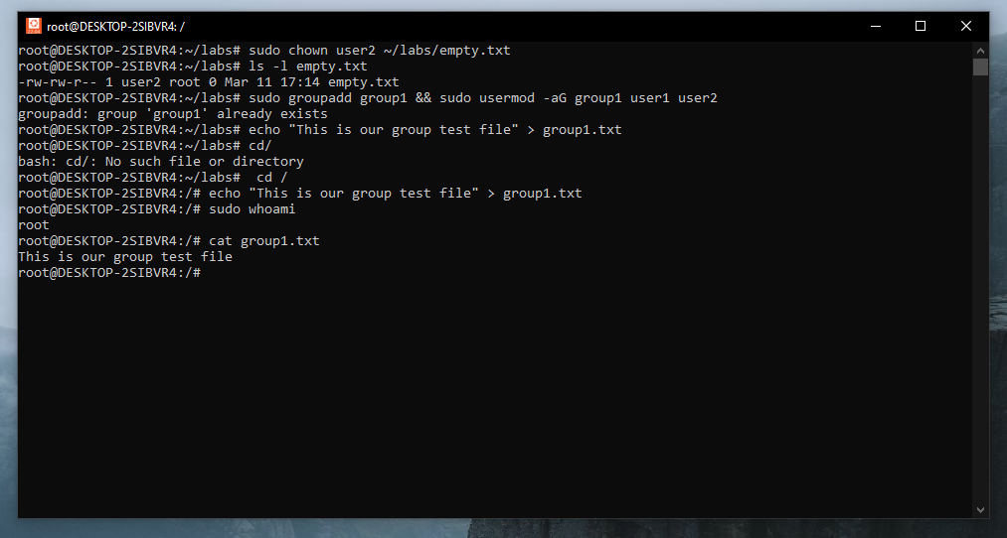  
23. Change the group of the file to one of your users;

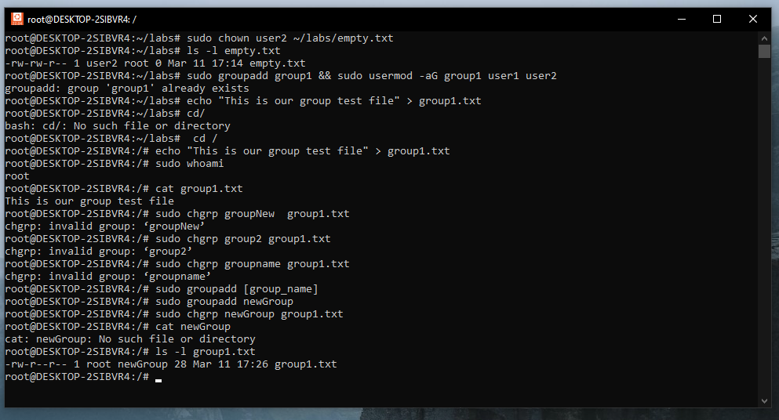

24. Give members of the group group1 read/write access to this file?

